## 

**Ingalls Unified School District #477**

**P.O. Box 99**

**Ingalls, Kansas 67853-0099**

[***www.ingallsusd477.com***](http://www.ingallsusd477.com)

Randy Rockhold Skyler Lightner Ted Brown

*Superintendent Elementary Principal Principal*

*620-335-5136 620-335-5134 620-335-5198*

*Fax: 620-335-5678*

Dear Parents,

On behalf of the staff at Ingalls Elementary School, I am happy to welcome you to the 2023-2024 school year! We are looking forward to a productive partnership with you to ensure our children can achieve their highest potential. We recognize that to be successful in school, our children need support from both the home and school. We know a strong partnership with you will make a great difference in your child’s education.

As partners, we share the responsibility for our children’s success and want you to know that we will do our very best to carry out our responsibilities. We ask that you guide and support your child’s learning by ensuring that he/she:

**1) Attends school daily and arrives on time, ready for the day’s learning experience.**

**2) Completes all homework assignments given by teachers.**

**3) Reads daily to develop a love for reading and to improve literacy skills.**

**4) Shares school experiences with you so that you are aware of his/her school life.**

**5) Informs you if he/she needs additional support in any area or subject.**

**6) Knows that you expect him/her to succeed in school and go on to college or careers.**

I am attaching a copy of our school handbook so that you and your child can review them together. If you have any questions about the rules and expectations, please feel free to contact me or to discuss them with your child’s teacher. It is very important that you and your child are fully informed regarding standards related to appropriate behavior for a safe and productive school year.

The wonderful staff at Ingalls Elementary School and I feel privileged to be a part of this school family. We thank you for your support and look forward to working with you in the future.

Sincerely,

Skyler Lightner

Ingalls Elementary Principal USD #477

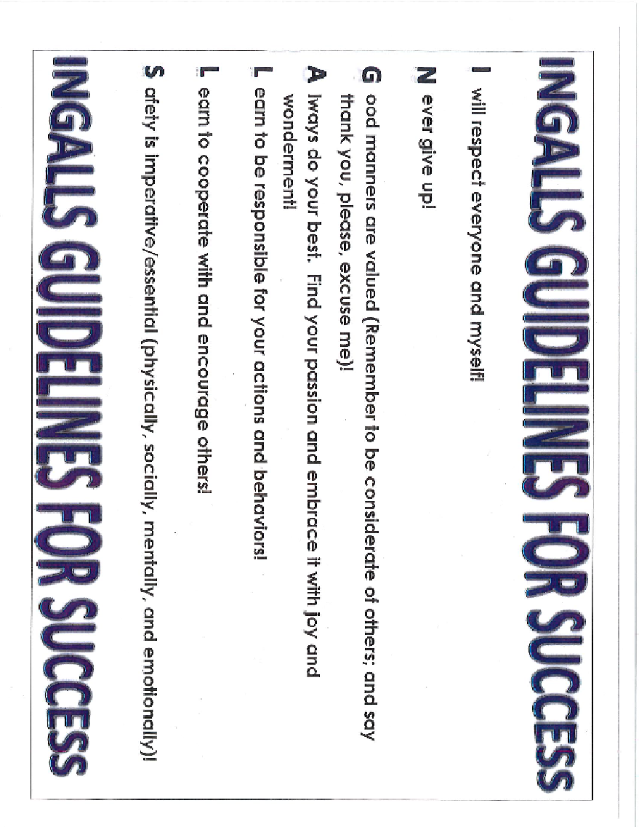

**Ingalls USD 477 Mission:**

Ingalls is committed to maintaining the core values of a small rural school with a family-like atmosphere. USD 477 utilizes relevant instruction and shared leadership to provide academic, social, emotional, and character education opportunities. This focus on the whole person enables all school community members to flourish. The Ingalls school community values the individual student and strives to meet each and every need. Relationships, relevance, responsive culture, and rigor are our priority as we prepare every child for career, vocational, and college success. We will ensure students develop the academic skills, cognitive skills, technical skills, employability skills, civic responsibility, and character necessary to be productive citizens.

**Ingalls USD 477 Vision:**

As a small rural school Ingalls strives to provide a real-world learning environment where each student is given the academic, social, and emotional support to be successful through every phase of life. An integrated curricular/co-curricular approach will ensure graduates are prepared to be successful in the workforce, in the completion of an industry recognized certification, or successfully complete a post-secondary education. Diverse learners will develop the necessary skills through rigorous academic curriculum, relevant and self-directed learning, service learning as a way to become community stewards, opportunities to create mind-body connections as well as community connections, and individual plans of study to ensure each student is informed and receives the needed learning opportunities to pursue the goals they have established.

**USD 477 Core Values** – USD 477 firmly believes that students can most readily achieve their potential when the entire community is invested in student learning – ensuring all students develop skills and attitudes so they will:

**B**elieve they can continually grow and advocate for myself.

**U**ltimately prepare themselves academically, cognitively, socially, emotionally, and develop character that will enable them to be all they dream to be.

**L**isten with understanding and empathy, think flexibly, develop a questioning attitude; Consider what information is needed, choose strategies to get that information; Consider the input of others; Generate alternatives; Weigh options

**L**earn to be clear when speaking and writing; strive to avoid generalizations, distortions, minimizations, and deletions.

**D**evelop a commitment to remaining open to continuous learning: Be open to new experiences to learn from; Proud and humble enough to admit when I don’t know; Welcome new information on all subjects, consider prior knowledge and experience to develop informed decisions; Apply knowledge beyond the situation in which it was learned.

**O**riginality is novel and inspires one to be open to the little and big surprises in life; Allows one to respond with wonderment and awe – allows one to be intrigued by the world’s beauty, nature’s power, and vastness of the universe; Allows one to have appreciation for what is awe-inspiring and can touch my heart, creativity, imagination. Innovative thinking leads one to fulfillment of purpose.

**G**ive permission to laugh at self when I can, be willing to try something new and different, face my fear of making mistakes or coming up short and refuse to let the obstacles of life break me.

**S**top putting limitation on myself, take responsibility for my actions, remain calm when stressed or challenged, be thoughtful and considerate of others, and stick to the task at hand through completion.

**Ingalls Bulldog Traits - Habits of Success**

To ensure each student is prepared for success Ingalls will implement a comprehensive improvement initiative that will lead to student success through developing the following:

* Develop a culture where all community members will be treated with respect
* Develop independence and sustainability by instilling:
  + Self-Direction – Driving forward the actions needed to achieve goals with or without help
  + Curiosity – Being interested in lots of things and wanting to understand more, even if it is challenging
  + Purpose – Charting a course for life that is meaningful and will have an impact on the world
* Develop Perseverance Through
  + Resilience – Bouncing back and dealing with challenging or harmful situations
  + Agency – Making my own decisions and acting on them
  + Academic Tenacity – Overcoming distractions and persevering towards longer term goals
* Creating Productive Mindsets for Self & School Through
  + Growth Mindset – Believing that I can grow my intelligence, that I’m not just born with a fixed amount of it
  + Self-Efficacy – Believing that I can do something successfully
  + Sense of Belonging – Feeling like I belong in my school community
  + Relevance of School – Believing that school is valuable and the things I learn are interesting
* Creating a Culture of School Readiness Through
  + Self-Awareness – Being aware of what I think, feel, do, my strengths and weaknesses, and the impact I have on other people
  + Empathy/Relationship Skills – Understanding how others might feel and having the skills to maintain strong relationships with people
  + Executive Functions – Concentrating, staying organized, juggling lots of things happening at once, and planning for the future
* Facilitate a School Environment That Ensures Healthy Social/Emotional/Character Development
  + Attachment – Having a strong bond with an adult who cares about me
  + Stress Management – Figuring out how to become calm and balanced when situations get stressful
  + Self-Regulation – Directing and maintaining my attention and emotions
  + Access to social/emotional support through group and individual intervention initiatives

**TABLE OF CONTENTS**

**Ingalls Elementary Goals**

**Board & Staff Members...........................................................................................1**

**Communication with the School**

**Grievance Procedures**

**Medication Policies**

**Health Reminders.......................................................................................................2-3**

**Proof of Identity of School Children**

**Kansas School Safety Hotline**

**Asbestos.......................................................................................................................3-4**

**Statement of Non-Discrimination**

**Student Insurance**

**Book Rental Fees**

**Meal Program..............................................................................................................4-5**

**Meal Prices**

**School Closings Due to Inclement Weather**

**School Day/Morning Procedures................................................................................5**

**Progress Reports/Grading Scale/Cards**

**Honors Recognition**

**Honors Banquet……………………………………………………………………....6**

**Citizenship Grade Rubric……………………………………………………………7**

**Field Trips**

**Promotion/Retention Attendance/Tardy**

**Attendance…….……………………………………………………………………...8-9**

**Tardiness**

**Support Services**

**Label Items……………………………………………………………………...……9**

**Valuables & Money**

**Bus Conduct**

**Leaving School Grounds…………………………………………………………….10**

**Traffic Safety**

**Student – Event Attendance Policy**

**School Pictures**

**Drop from Enrollment**

**Assessments**

**Telephone Use………………………………………………………………………..11**

**Dress Code....................................................................................................................12-13**

**Discipline/Conduct**

**Bullying**

**After School Detention**

**In-School Suspension**

**Out-of-School Suspension……………………………………………………………13-14**

**Weapons.........................................................................................................................14**

**Cleanliness**

**Pets**

**Student Assistance Team……………………………………………………………….15**

**Recess**

**Library**

**Physical Ed**

**Instrumental**

**Bicycles..............................................................................................................................16**

**Out of District Policy....................................................................................................17-20**

**Chromebook User Agreement …………………………………………………………21**

**School Supply List………………………………………………………………….…22-23**

**Internet Use Policy……………………………………………………………………24-25**

**District Calendar…………………………………………………………………………26**

**Unpaid Meal Charges Policy…………………………………………………………….27**

Ingalls Elementary Schools Goals

|  |
| --- |
|  |

**Provide a safe learning environment where students will have the opportunity to learn, to develop, and to practice those academic skills and interpersonal skills needed to be productive and successful citizens in a changing democratic society.**

**Strive for varied and flexible instructional and learning procedures that individual learning styles require for creative thinking and high self-esteem.**

**Provide systems of communication for parents, students and staff to better understand the school goals.**

**INGALLS GRADE SCHOOL STAFF**

**Superintendent-Randy Rockhold Elementary Principal-Skyler Lightner**

**Secretary- Ana Quint Counselor-Stacy Salem**

**Pre-K-Debbie Jury Speech Pathologist- Valerie Shultz (via virtual)**

**Kindergarten-Erica Pelischek Special Ed-Lyndi Meier**

**First- Ty Poer Vocal/Band-Luke Johnson ( Pre-K-12th)**

**Second-Jennifer Beach In House Substitute- Nathan Lowther**

**PE-Terra Simon Third- Terri Meis**

**Kitchen Manager-Jeanette Loewen Fourth- Tiffany Wilkison**

**Cook- Melissa Smith Fifth- Michaela Strecker**

**Head Custodian-Juana Robles Para(s)- Lupe Andazola, Mariel Barraza**

**Custodians- Nidia Robles, Carolina Estrada, Bulma Galaviz (ESOL), Heidi Markel (Library),**

**Daniel Robles-(custodian cont.) Jessica Radcliff, Emily Richardson**

**Transportation-Melanie Turner Intervention- Tyler Meng (Pre-K-12th)**

**School Psychologist -Julianne Kemmerer**

**BUS DRIVERS**

**Annette Doll**

**Ronnda Singhisen**

**Melanie Turner**

**Jessica Dunigan**

**ADMINISTRATIVE STAFF**

**Randy Rockhold-Superintendent -335-5136**

**Skyler Lighter – Elementary Principal-335-5134**

**Ted Brown-HS Principal -335-5198**

**Shelly Whipple-Athletic Director – 335-5135**

**SCHOOL BOARD**

**Matt Stein-President – 620-339-5433**

**Joanna Schmeeckle -Vice President - 335**-**5240**

**Jeremy Salem – 620-408-7883**

**Kyle Averhoff – 620-271-1192**

**John Minet – 335-5500**

**Jeremy Simon – 620-271-4499**

**Karen Walker – 335-5525**

**Grade School Office – 335-5134 High School Office – 335-5135**

**Board of Education Office – 335-5197**

**1**

COMMUNICATION WITH THE SCHOOL

It is important that parents and teachers work together to provide the best education for each child. Teachers and the principal can be contacted before and after school. Teachers will send a schedule home so that parents will know when they have plan time. This would be a good time to call. Phone calls can be made to teachers and the principal in the evenings in emergency situations.

Notes to the teacher and notes from the teacher are also an important communication tool. Student work can indicate to parents how well their child understands a concept. Student comments about the classroom can be an indicator of how well the student thinks he/she is doing and can provide clues about areas of achievement and/or concerns.

### GRIEVANCE PROCEDURE

Disagreements should be discussed with persons directly affected. If a disagreement still exists, a teacher’s decision may be appealed to the principal. A principal’s decision may be appealed to the superintendent, the superintendent’s decision to the Board of Education, and Board’s decision to the courts.

### MEDICATION POLICY

Guidelines were developed for administration of medication during school time with the health and safety of the student in mind and are in compliance with state law.

1. Written request from the physician or dentist should accompany all medication to be administered, including **“over the counter”** drugs.
2. Written request from the parent/guardian should also accompany **all** medication.
3. All medication must be brought to school in the original container with proper labeling from the pharmacy stating the name of the medication, the dosage, and time to be administered.
4. **“Over the counter” medication cannot be maintained on any school premises unless a prescription is provided along with written permission to administer from the physician and parent.**

### HEALTH AND HEALTH REMINDERS

Minor injuries will be treated at school. Students who become ill at school will be allowed to go home only if picked up by the parent or guardian or another responsible person designated by the parent or guardian. We ask that all parents leave **two emergency** **numbers** of someone who will take responsibility for your sick child if you are not available.

**2**

**(Health Cont.)**

**Fever:** A student should be **fever-free for 24 hours** before returning to school.

**REMINDERS:** parents of **new students** – **Immunizations** and **physical exams are needed for attendance in school.** Students need to bring proof of receiving the immunization with them to enrollment. Students not having proper immunizations will not be allowed to attend school.

**HEAD LICE:** If head lice are detected during school hours, it is required that parents or guardians remove their child from school until proof of proper treatment is presented to the school. Parents or guardians are responsible to always remove their children from school during active/live lice.

# PROOF OF IDENTITY OF SCHOOL CHILDREN

Senate Bill 593 provides that whenever a child enrolls in a public or non-public school for the first time, the school board is required to secure proof of identity of the child. **Proof of identity** is either (a) **a birth certificate** for a child enrolling in kindergarten or the first grade, a **copy of** the **court order** placing the child in the custody of the Secretary of Social and Rehabilitation Services (SRS), or a **certified transcript** or other similar pupil record of a child enrolling in grades 2 through 12, or (b) any other documentary evidence that a board determines to be satisfactory proof of identity. If proof of identity is not provided to the school board within 30 days of enrollment, the school board must notify the local law enforcement agency which then must promptly investigate the identity of the child. No person claiming custody of the child may be informed of the investigation while it is occurring.

# KANSAS SCHOOL SAFETY HOTLINE

Call 1-877-626-8203 (toll free) to report any information that might threaten the safety of school or students. The hotline is available 24 hours a day, 365 days a year to report impending school violence to the Kansas Highway Patrol.

The school staff encourages any student who feels threatened to share their feelings with an adult at school who they trust.

**ASBESTOS**

This notification is to make you aware that our school facilities are in compliance with the Asbestos Hazardous Emergency Response Act of 1986. As per AHERA our facilities undergo mandatory 6-month surveillance and a mandatory 3 year re-inspection of all asbestos material to assess condition.

**3**

(**Asbestos cont.)**

All inspections, operations and maintenance of the material is conducted by a certified Inspector/Management Planner, as required and the records of all activity are available in the management plan binder, located in the school office or the Central Office.

# STATEMENT OF NON-DISCRIMINATION

Students, their parents/guardians, and the employees of Unified School District #477 are hereby notified that this school district complies with the Title IX of the Education Amendments of 1972, Section 504 of the Rehabilitation Act of 1973, and Title VI of the Civil Rights Act of 1964. Board of Education policy prohibits discrimination based on sex, handicap, age, race, creed, color or national origin in district programs and activities.

# STUDENT INSURANCE

The district provides supplemental coverage for students. This means that parents must submit the claim to their own insurance company for payment before the district can submit the claim to its carrier.

Twenty-four-hour coverage insurance is available for all students at a very reasonable cost. This is excellent for families with no health insurance coverage. Forms are available in the school office during enrollment, but enrollment in the program should be made soon after the beginning of school.

# BOOK RENTAL FEES

Student textbooks and workbooks rental fee is **$65.00** for grades K-5 and **$70.00** for 6-12. The book rental fee covers the normal use of books for the school year. Books that are lost or damaged must be replaced by parents at the district’s purchase cost.

# MEAL PROGRAM

Students are encouraged to eat a nutritious lunch each day. The National School Lunch Program is designed to give students the opportunity to select the foods which they want to eat and reduce food waste. The hot lunch program allows each child to select a minimum of three different food items and milk. The daily lunch will provide approximately one-third of an individual student’s daily nutritional needs.

A breakfast program is also available.

Meal money should be sent to school on the first day of each week. Please pay by the week, two weeks, or monthly. Do **not** send money on a daily basis. **Meals must be paid for in advance.**

**4**

(**Meal Program cont.)**

Applications for free and reduced meals are available at the school office.

Parents have an open invitation to eat lunch with their child.

We encourage you to eat lunch with your child at least once during the year. Arrangements can be made through the school secretary by **10:00** a.m.

**MEAL PRICES:** $3.00 PK-4 Student Lunch ($ 15.00 per week)

$3.50 5-12 Student Lunch ($ 17.50 per week)

.40 Reduced Student Lunch ($ 2.00 per week)

.50 Extra Milk ($ 10.00 per month)

$ 4.50 Adult/Guests Lunch

$2.50 PK-12 Breakfast ($12.50 per week)

.30 Reduced Student Breakfast ($1.50 per week)

# SCHOOL CLOSING DUE TO INCLEMENT WEATHER

When the weather or roads become questionable, phone calls will come directly to you through our automated **Go Edustar** system. It is imperative that phone numbers and contact information is kept current. The district will try to have the information broadcast **before 6:00 A.M**. Closing information will also be posted on television and radio stations.

# SCHOOL DAY

The school day is from 8:00-3:50. For safety reasons, students should not arrive on the school grounds before 7:45. Students are asked to the leave the building by 4:00 unless with adult supervision.

**MORNING PROCEDURES**

Students are asked to arrive at school between 7:45 and 7:55. Students who are eating breakfast are to go directly to the cafeteria. Student’s not eating breakfast should report directly to their classroom.

# 5

# PROGRESS REPORTS AND GRADE CARDS

Progress reports will be sent home with students in the middle of every

nine weeks. Grade cards will be sent home with students or given out at parent/teacher conferences at the end of each nine-week grading period, except for the last nine-week period. These reports are a summation of the work that the student has completed during nine weeks of effort. They are only one indicator of the student’s progress. The following is a breakdown of the elementary grading scale: (*Only grades 3rd – 5th will portray a letter grade*)

**PK – 2nd**  **3rd – 4th**

**S = Satisfactory A = Outstanding**

**U = Unsatisfactory B = Above Average**

**X = Is Well Developed C = Average**

**+ = Shows Improvement D = Below Average**

**- = Needs Improvement F = Failing**

Please contact the teacher for a more detailed report of the student’s specific areas of learning or if there is some other concern. The last nine-week grade cards will be mailed home at the end of the school year.

### HONORS RECOGNITION

### Each 3rd, 4th, & 5th grade student who has all A’s during the current school year will receive a certificate of recognition at the end of the school year. Each 3rd, 4th, & 5th grade student who has all A’s & B’s during the current school year will receive a certificate of recognition at the end of the school year. Each 3rd, 4th, & 5th grade student who has exemplary citizenship throughout the current school year will receive a certificate of recognition at the end of the school year. Each 3rd, 4th, & 5th grade student who has perfect attendance throughout the current school year will receive a certificate of recognition at the end of the school year.

### 

**6**

Ingalls Elementary Citizenship Rubric

Students are graded on the basis of their citizenship. Citizenship grades are based on:

- Mindset

- Social Responsibility

-Self-control

The following are the citizenship grades given monthly:

-10-Consistently demonstrates desirable qualities of good citizenship - 7-Sometimes demonstrates desirable qualities of good citizenship. - 5-Rarely demonstrates desirable qualities of good citizenship.

|  |  |  |  |
| --- | --- | --- | --- |
| Behavior/Skill | 10-Consistently | 7-Sometimes | 5-Rarely |
| Mindset |  |  |  |
| -takes initiative with learning, and thinks inde endently |  |  |  |
| -perseveres, keeps trying even when things are difficult, seeks/accepts feedback |  |  |  |
| -contributes to a positive learning environment |  |  |  |
| Social Res onsibility |  |  |  |
| -listens actively to others and contributes to discussion when appropriate |  |  |  |
| -mindful of school rules and is a caring/ helpful citizen in class |  |  |  |
| -respectful and cooperative with staff and classmates |  |  |  |
| -demonstrates integrity/honesty in learning |  |  |  |
| Self-control |  |  |  |
| -stays calm, handles frustration appropriately, keeps hands to themselves |  |  |  |
| -uses appropriate voice tone, disagrees appropriately, gets teachers and peers attention appropriately |  |  |  |

**7**

### FIELD TRIPS

Each year students take various field trips to enhance their education. Parents/Guardians sign a field trip permission form at enrollment, which allows the student to go on field trips that are within the regular school hours. Any other field trips that a student may attend, outside school hours will have a permission slip the parent/guardian must sign specific to that trip. Students that do not have permission from the parent/guardian will not be allowed to go on a field trip outside school days. A student that does not represent him/her, parents, or the school in a positive manner may be denied the privilege of attending field trips.

### PROMOTION AND RETENTION

Under normal circumstances students are expected to successfully complete their schoolwork to be promoted. Students who have failed to complete their work or have excessive absences may be recommended for retention. The teacher of record may recommend a student for promotion or retention. If a student is recommended for retention a notice will be sent to parents or a conference will be held.

If the parent or guardian disagrees with the recommendation, they may request a review committee composed of the parent, parents, or guardian, principal, student, present and past teacher (if possible) and the guidance counselor.

The committee will review the student’s progress, academic achievement, chronological age, life experience, mental maturity, physical size, attendance, and social development. Students may then be promoted or retained in a grade depending on the recommendation of the committee.

### ATTENDANCE

### Regular attendance is one of the best predictors of success in school. It is necessary that your children come to school regularly if they are to progress with their class. Everyday something new is presented in each subject and if your children miss the introduction of new work, it is difficult for them to make it up.

### Attendance at any school activity is discouraged if a student is not in class during the regular school day.

### Students who are not in attendance during the entire school day

### will not be allowed to participate in after school activities without prior approval by the principal.

**8**

**(Attendance cont.)**

**Prearranged Absence: If you know you are going to be gone for an extended period of time (family vacation, group trip) you must make arrangements with the office and your teachers regarding makeup work.**

**Unexcused Absence: A truancy report will be filed with the SRS office for any student under 14 years of age with three (3) consecutive unexcused absences or five (5) nonconsecutive unexcused absences.**

**Tardy:** Is entering the classroom any time after instruction begins. Parents of students that have a high absentee rate, more than **10 days** in a semester, excused or unexcused, will be notified by mail or telephone call and a conference may be necessary to determine the cause and a solution for so many absences. A doctor’s note may be required for a student missing too much school.

# SUPPORT SERVICES

Ingalls Grade School has an elementary counselor available for individual student concerns and problems. Students may ask to see the counselor, may be recommended by the teacher, or may be recommended by the parent.

Parents, teachers, or other school personnel may recommend a student that has a unique learning or behavior problem, or handicapping condition be referred for special education. These services are available through the

Special Education Cooperative. Such services could include speech therapy, occupational therapy, physical therapy, LD services, EMH services, ED services, teacher for D, or other type of special education services.

### LABEL ITEMS

Students should mark all personal items such as jackets, gym shoes, workbooks, or other personal items, which might become misplaced. Please mark with ink or permanent marker. A lost and found box is kept in the office.

**CLASS PARTIES**

New health regulations require that all food items brought to school to be shared must be packaged food items. Homemade foods cannot be allowed.

**9**

### VALUABLES AND MONEY

Students should not bring valuables or unnecessary money to school. If it is necessary for a student to bring such to school, it should be kept in the office for safekeeping.

**It is the responsibility of the student to care for their personal items at school. The school will not be responsible for any property owned by the student or parents that is brought to school and is broken or stolen. This includes money, band instruments, toys, valuables, etc.**

### BUS STUDENTS

When school is dismissed bus students are to go directly to the bus loading area. Good conduct is expected while waiting in line for your bus. Students must always follow the bus rules and the instructions of the driver.

Bus transportation for all students who live on regular established bus routes will be provided by the school district.

We endeavor to operate all school buses as nearly on schedule as weather permits. Students should be ready to board the bus when it arrives. If you live in the country and your child is not riding the bus, please watch for the bus and wave it on. **Students who ride the bus to school in the morning are expected to ride it in the evening unless a written request by the parent or guardian is sent to the school office.** If you wish to pick up your child in the evening, you should notify the bus driver.

**BUS CONDUCT:**

A list of bus rules will be posted in each bus and reviewed by each driver. Students who violate these rules of bus conduct will be referred to the principal’s office by a written misconduct report and appropriate action will be taken. Continued misconduct or a violation of safety rules by a student may result in suspension of riding privileges.

### LEAVING SCHOOL GROUNDS

No student will be permitted to leave the school area during the day unless the parent sends a note or phones in to the office giving permission to leave. Parents must sign students in and out at the elementary school office before students will be allowed to leave or return. Please inform the teacher or office in advance if possible.

**10**

### TRAFFIC SAFETY

If you walk to school, be sure to cross streets at the crosswalks. Do not cross in the middle of the block and never step into the street or between parked cars. Walk on the left side facing traffic where sidewalks are not

available. Bicycle riders must be especially careful when leaving the school grounds and must obey all traffic laws. Parents are asked to notice and carefully observe all traffic signs in the school area. Bus students being picked up by parents should walk in front of buses making sure the driver can see you. **Never walk between buses.**

**STUDENT – EVENT ATTENDANCE POLICY**

All students who attend events sponsored by the school district must remain in the event area at all times. Students who attend events will be admitted to the activity, and if they choose to leave the building they will not be allowed to return. Students who choose not to remain in the event area will be taken to their parent/guardian and given a warning. If a student refuses to stay in the event area after a warning they will lose attendance privilege for the remainder of the event season.

# SCHOOL PICTURES

The school will have individual student pictures taken during the fall to be used in the yearbook and again in the spring for group pictures. Families are under no obligation to purchase any of the pictures.

#### DROP FROM ENROLLMENT

After 10 days, a student that plans to be gone for an extended period will be dropped from the register. When the student returns, the student will re-enroll.

### ASSESSMENTS

Ingalls Elementary School administers various assessments during the school year to determine student progress in their learning and for the purpose of reporting results and information to the State Department of Education.

# TELEPHONE USE

The telephone at Ingalls Grade School is a business phone. Students

will be allowed to use the phone in emergency situations. Students will be discouraged from using the phone to get library books, homework, musical

instruments, or arranging after-school visits.

**11**

The office will be glad to relay important necessary messages from parents to students. Please do not ask to speak directly to your child except in an emergency.

(Cont.) Students **will not be allowed** to use their cell phones during the school day. If a student brings their phone, it needs to be left in their locker and turned off upon arrival to school.

### DRESS CODE

Appearance does affect the learning atmosphere of a school. Students are encouraged to dress in a neat and attractive manner that reflects pride in themselves and their school. **Clothing should be appropriate for the weather.** Shoes with “cleats” on the soles are not to be worn to school.

To aid students and parents in determining acceptable school dress, the following guidelines have been developed:

1. Everyone must wear shoes.
2. Hats, caps, and other forms of headgear are not to be worn in any district building. This includes during home and away activities of the elementary, middle, or high schools.
3. Tank top shirts will not be allowed to be worn in school unless worn with a shirt underneath.
4. Transparent clothing and fish net shirts that expose the body and two-piece outfits that expose the bare midriff are not acceptable at school short shorts will not be allowed.
5. Non-prescription sunglasses will not be allowed to be worn in the school buildings of the district.
6. Pants or shorts must be worn on or above the hips.
7. No gang symbols or gang-affiliated attire will be allowed to be worn at school or any school activity. Examples: Overall straps must be over shoulders, no sagging pants, no excessive oversized clothing, no brown or black lipstick, bandannas, exposed boxer shorts, hanging belts. Our district will use the Gray County Law Enforcement Center for references.
8. No wallet chains of any length will be allowed.
9. Students are not permitted to wear or possess any items that describe in picture, word, or in reference, profanity, obscenity, alcohol, drugs or anti-patriotism.
10. Personal grooming should be done in the restroom only.
11. Because of safety hazards involved in some class activities (i.e., projects, field trips, etc.) students in these activities must dress suitably to the conditions, as the instructor requires.

**12**

1. Any student, who represents the school in extracurricular activities, must dress in accordance with the sponsor’s requirements, subject to prior approval of the administration.
2. Pierced earrings worn in the ear(s) is the only acceptable form of body piercing that will be allowed.

If the student’s behavior or other attribute is in violation of these provisions, the principal or his designee will request the student to make the appropriate corrections. If the student refuses, the parent/guardian may be notified and asked to make the necessary correction. The principal shall take appropriate corrective and disciplinary action as necessary.

### DISCIPLINE/CONDUCT

Good student behavior is what is expected at Ingalls Elementary Schools. Students will be expected to show respect by their words and actions to teachers, parents, and other adults and fellow students. Ingalls Elementary Schools recognizes that discipline in the school must be maintained so that an atmosphere conducive to learning will be present for all students. Discipline is a joint responsibility of the student, parent, all teachers associated with the student, in addition to the homeroom teacher and the principal.

# BULLYING

# Bullying of any type shall not be tolerated in the school setting. Ingalls Elementary School will endeavor to maintain a learning and working environment free of bullying. Bullying is defined as the act of one or more individuals intimidating one or more individuals through either verbal, physical, mental, cyber bullying through electronic devices or written interactions. Bullying can cause undo anxiety relative to attending school, playing on the playground, participating in or attending activities, or riding on the bus. This can adversely affect student or employee performance.

# AFTER SCHOOL DETENTION

Detention will begin at the end of the school day and last until 4:05. When assigned a detention, it will be served the next day so parents may arrange transportation for the student, unless the student and parent wish to have the detention served that day, and this option is acceptable with the teacher. Parents will be notified about all detentions either by mail or a phone call. If a student skips a detention, then it will double.

**13**

**IN-SCHOOL SUSPENSION**

In-School Suspension may be used as a step before out-of-school suspension. When a student is assigned an in-school suspension, the student

will have the right to do class work, but the student will be:

* Assigned to the office for the period of the suspension.
* Removed from class or classes and will be isolated from all students for the duration of the in-school suspension.

**OUT-OF-SCHOOL SUSPENSION**

**(Out of School Suspension cont.)**

In cases where student behavior results in a severe disruption, the child will be sent immediately to the principal. Misbehavior will be considered severe if a child:

1. Willfully assaults or inflicts harm on another child or school employee.
2. Displays gross disrespect toward school personnel.
3. Engages in gross disorderly conduct, i.e., behavior which severely or continuously disturbs the peace or good order of the school environment and the rights of others to obtain an education.
4. Engages in vandalism or theft.
5. Continuously refuses to abide by classroom and/or out-of-classroom rules.

Students who have caused severe disruptions are subject to suspension from school for a one to ten-day period of time. Students who maliciously destroy or deface school property or personal property of others will be expected to make payment in full to replace or repair the property and are also subject to suspension, expulsion, and possible police referral.

**14**

**WEAPONS**

A student shall not knowingly possess, handle, or transmit any object that can reasonably be considered a weapon on the school grounds or off the school grounds at a school activity, function or event.

This policy shall include any weapon, any item being used as a weapon or destructive device, or any facsimile of a weapon.

Possession of a firearm shall result in expulsion from school for a period of one year (180 school days), except that the superintendent may recommend that this expulsion requirement be modified on a case-by-case

basis under the provisions of the JDC (Probation). Students violating this policy shall be referred to the appropriate law enforcement agency (ies).

As used in this policy, the term “firearm” means any weapon (including a starter gun) which will or is designed to or may readily be converted to expel a projectile by the action of an explosive, the frame or receiver of any such weapon, or any firearm muffler, or silencer, or any destructive device.

As used in this policy, the term “destructive device” means any explosive, incendiary or poison gas: bomb, grenade, rocket having propellant charge of more than four ounces, missile having explosive or incendiary charge of more than one-quarter ounce, mine, or other device like any of these devices.

**CLEANLINESS**

Students are expected to take pride in helping to keep all areas clean and in order. Wastepaper and other trash will be put in proper containers in classrooms, restrooms, or any other area. Floors should be kept clean and free of trash, books, or other personal items. Show citizenship and pride in your school by keeping the desks, walls, and other areas of the school free of marks or other damages. Walk only on the sidewalks and pavement during muddy weather. Shoes are to be reasonably clean before entering the building. Cleaning tools and solutions will be used only after asking the custodian.

**PETS**

Pets may be brought to school only with the teacher’s permission and arrangements made for them to be picked up after sharing. Students and parents are responsible for seeing that pets do not follow you to school. Pets are not allowed to ride the school bus with the student.

**15**

**STUDENT ASSISTANCE TEAM**

The Student Assistance Team (S.A.T.) consists of classroom teachers, special educators, school psychologist, counselor, and principal. This team provides a structure for dealing with behavioral and academic concerns for all students and can provide teachers and parents with the support they need for working with most students that may be struggling. This process works well in the prevention of more serious problems developing for the student in school. Students can access the S.A.T. in three different ways: (1) they can be referred by a teacher, staff person, or parent; (2) they can refer themselves to the team; (3) if they violate the student code of conduct and are referred for disciplinary action. Parents access the process in two ways: (1) they can refer their child if they have concerns; and (2) they can be requested to provide the team with additional information and support in the intervention of their child. For further informationabout the process of the S.A.T. please contact the school counselor or Mr. Rockhold.

# RECESS

Recess plays an important role in the students’ social and personal development. All students are expected to participate in recess. When the

temperature or wind chill is extreme, we will have inside recess. Please try to be aware of the appropriate dress needed for different outdoor weather situations. The school will provide playground equipment that can be used at recess.

**LIBRARY**

The checking out of materials by students represents a contract. The student agrees to borrow the book for a two-week period and to return that book in the same condition. If a student fails to return a book or damages the book, then a replacement fee will be charged to replace the book. The fee for a lost book will be charged and refunded only if the book is found and returned by the end of the year. The privilege of checking out books will be suspended until this matter is taken care of. Parents will be notified by mail when this occurs.

## PHYSICAL EDUCATION

Students are required to have gym shoes for participation in physical education classes. The gym shoes cannot be the ones worn daily because they may have dirt and stones in the treads.

Students are required to participate in physical education to the best of their ability. Please ask the doctor for a note if your child needs special arrangements in P.E.

**16**

# INSTRUMENTAL MUSIC

Band is available for 5th and 6th grade students. Students should receive information about band during the first part of the school year. If there are specific questions, please contact the music instructor.

**BICYCLES**

Students may ride their bicycle to school. Students should ride single file on the right side of the street, watch for cars, obey traffic signs, and use

hand signals. Upon getting to school the bicycles must be placed in the bicycle rack at the back of the school. If we find that a student is being careless, discourteous, or not following safety rules, we will call the parent.

**16**

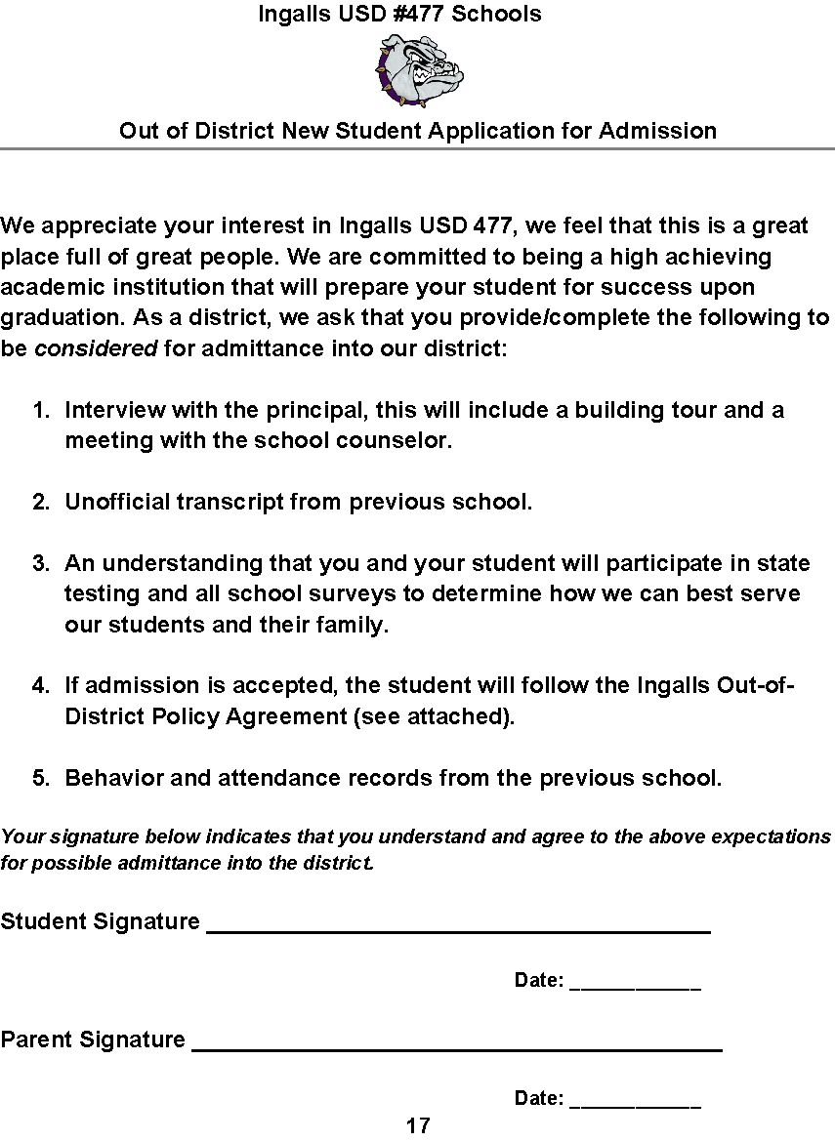***Student Information***

**Student Name: ________________________________________**

**Grade in School: __________**

**Parent/Guardian Name: ______________________________**

**Parent/Guardian name: ______________________________**

**Mailing Address: ____________________________________**

**Parent Phone Number: _______________________________**

***Previous/Current School information***

**School Name: __________________________________**

**City_____________________ State: ________**

**Phone Number: _________________**

**Fax Number: _________________**

**Principal Name: _______________________________**

**Counselor Name: _______________________________**

**18**

**Please explain why you are interested in transferring to Ingalls:**

________________________________________________________________________________________________________________________________________________________________________________________________________________________________________________________________________________________________________________________

***School Performance***

**Current Grade Point Average (GPA): _________**

***Behavior and Disciplinary Performance***

**Please indicate any previous or pending disciplinary actions:**

 **Detentions**  **In School Suspension**

 **Out of School Suspension**  **Expulsion**

**If you marked any of the above infractions, please explain further:**

____________________________________________________________________________________________________________________________________________________________________________________________________________________________________________________________________

**19**

**Ingalls Unified School District #477**

**P.O. Box 99**

**Ingalls, Kansas 67853-0099**

[***www.ingallsusd477.com***](http://www.ingallsusd477.com)

Randy Rockhold Skyler Lightner Ted Brown

*Superintendent Elementary Principal JH/Principal*

*620-335-5136 620-335-5134 620-335-5198*

*Fax: 620-335-5678*

Ingalls USD #477

OUT-OF-DISTRICT AGREEMENT

Ingalls USD #477 may allow students who reside outside district boundaries to attend Ingalls Schools.

The following guidelines must be honored by all out-of-district students and parents/guardians:

* All out-of-district students and parents/guardians must sign the “Ingalls Out-of District Policy Agreement,” prior to attendance each school year.
* Out-of-district students must meet and maintain the following district expectations:
* Out-of-district students will not be accepted if he/she is serving a long-term expulsion.
* Ingalls USD #477, at the point of enrollment, will honor all short-term suspensions, from a prior district.
* To maintain enrollment/attendance at Ingalls Schools, out-of-district students must acquire at least a 2.0 G.P.A at the end of each semester. A student who falls below a 2.0 G.P.A will be placed on an academic contract for a 9-weeks probationary period to bring the G.P.A up. The administration will review the student’s progress at that time to determine if he/she has met the terms of the contract and whether they may continue to attend.
* To maintain enrollment/attendance at Ingalls Schools, out-of-district students must conduct good behavior while attending.
* Continual minor disciplinary infractions may result in dismissal.
* Failure to maintain good attendance will result in dismissal.
* Failure to pass at least three or more core classes for the semester will result in dismissal.
* I agree that I and/or my student will participate in state testing and all school surveys to determine how we can best serve our students and their family.

Ingalls USD #477 has the right to refuse any and all out-of-district students at the discretion of administration and the board of education. Existing class sizes may have an effect on admittance of out-of-district students.

Ingalls USD #477 has the right to make referral checks on out-of-district students.

I have read, understand and agree to the Ingalls USD #477 Out-Of-District Policy.

Student______________________________________________ Date______________________

Parent/Guardian_____________________________________ Date______________________



20

**Ingalls Schools Chromebook User Agreement**

**Student Chromebook Use and Expectations:**

* Elementary and MS student’s Chromebooks must stay at school; HS Students may take them home.
* Only use a school approved background.
* Use your school email only.
* Lower the lid when the teacher is talking.
* Only use your Chromebook in the classroom, in a clear, flat space.
* Chromebooks are not allowed in the bathroom, locker room or during lunch.
* Use your Chromebook in the classroom when instructed to use it.
* Do not visit pages or documents that are not directly related to your assignment.
* Web browsing is for educational/school use only.
* School-approved games are allowed when teachers have given permission to play.
* Only school approved Apps and Extensions are allowed.
* Sound should be muted on Chromebook. Use of your headphones is permitted when granted by teacher.
* In your classroom, carry your Chromebook with the lid closed using two hands.
* When moving between classrooms place Chromebook in case, zipper and carry with handle.
* Do not place Chromebook in your backpack.
* Never throw, slide, drop or press hard on your Chromebook.
* No food or drinks allowed near the Chromebook.
* MS students must sign out of your Chromebook and shutdown at the end of each day; store it using teacher guidelines.
* Any damage to the student assigned Chromebook is the responsibility of the student.

**Please complete the information below to identify the student and their assigned device. Your signature indicates you have read and understand the Chromebook policies.**

Student Name: Grade:

Student Signature: *Student ID:

Parent Name:

Parent Signature: Date:

**Serial Number of Chromebook:

*The student id, if not known, will be completed by school personnel.

**The Serial Number and Color of case/sleeve will be supplied when the Chromebook is issued.

**CHARGES FOR LOST OR BROKEN TECHNOLOGY**

**CHROME BOOK - $250.00**

**CHROME CASE - $30.00**

**CHROME CHARGER - $25.00**

**TOUCH SCREEN - $150.00**

**Charging Port - $70.00**

**CHROME SCREEN - $50.00**

**CHROME KEYBOARD - $35.00**

21





**23**

**ACCEPTABLE USE POLICY**

**INGALLS USD #477**

**USD 477 Mission Statement**

The mission of USD 477 is to provide all students with a quality education in a safe, nurturing environment, encourages respect, and promotes a responsible work ethic.

**USD 477 Technology Mission Statement**

The technology mission of Ingalls Schools is to incorporate technology into the educational program to create technologically literate citizens who are marketable, successful, and contributing members of society.

**Purpose**

This Acceptable Use Policy sets forth the policies and guidelines for access to the school district computer system and acceptable use of the internet and other technology. Technology is meant to include electronic and digital devices including computers, personal digital assistants, the local area network, and the Internet provided by or used on the premises of USD 477. These guidelines apply to all users, including students and staff.

**Use is a Privilege**

Users are expected to use District technology to further educational and personal goals consistent with the mission of the School District and its policies. Access to the network is a privilege and with any privilege comes responsibility. If the responsibility is abused, access can be revoked. Access can be denied, and other disciplinary action taken for inappropriate use of the network. By signing this document, parents/guardians are agreeing to take responsibility for their child’s access to any inappropriate material or for other inappropriate actions concerning the district’s technology network.

USD 477 will inform users of acceptable, safe, and effective techniques for use of the internet. The district will also provide internet content filtering through software, hardware, or a combination of the two. It must be understood by users and parents that no method of filtering is completely effective.

**School District Web Site and Other Media Outlets**

Web pages on school sites may include student pictures and first name only unless their legal guardian requests in writing that such pictures are acceptable as long as names are not associated with pictures. Staff pictures and names may be posted unless otherwise requested.

**Unacceptable Uses/Behavior**

* Users will not attempt to gain unauthorized access to any computer system within the district or access another person’s files.
* Users will not attempt to deliberately disrupt the computer system or destroy data by spreading computer viruses or by any other means.
* Users will not use the district technology to access, view, upload, download, store, print or distribute pornographic or obscene material.
* Users will not use District technology to transmit or receive obscene, abusive, inflammatory, threatening or sexually explicit language or discriminatory (hate) literature.
* Users will not use district technology to engage in any illegal act or violate any local, state, or federal statute or law.
* Users will not alter or damage any part of the district network, including software and hardware, and will not attempt to bypass security or Internet filtering.
* Users will not post personal contact information about themselves or others. Such information includes addresses, telephone number, credit card information, and picture.
* Users will not use district technology to violate copyright laws or licensing agreements or use another person’s property without the prior approval of the owner or proper citation, including the downloading or exchange of pirated software or the copying of software to or from any school computer, and will not plagiarize works found on the internet.
* Users will not modify or damage another user’s data.
* Students will not use the District Network for **personal email, MSN Messenger or any other chat program, or any program for non-educational purposes (such as online games, etc.).**
* Any form of cyber-bullying is not acceptable and will not be tolerated.

**24**

**Consequences of Violations of Acceptable Use Policy**

Violations of the Acceptable Use Policy of USD 477 will result in disciplinary action. Three levels of disciplinary action will be enforced by administration. Any level of action may be selected depending on the severity of the violation. All Student Handbook rules and policies will be followed and enforced. The administration holds the right, depending on the severity of the abuse or misuse of technology, to take, add, or increase any penalties they and the Board of Education deem necessary.

LEVEL 1-WARNING: User would lose technology/internet privileges until a parent or guardian conference is held. Any additional loss of privileges as determined by the administration will be discussed at this conference. This can be enforced by semester.

LEVEL 2-PATTERN OF ABUSE, REPEATED ABUSE OR FLAGRANT VIOLATION: Any user who after a Level 1 warning continues to engage in serious or persistent misbehavior by violating the Acceptable Use Policy may have the computer/internet privileges revoked for the entire year.

LEVEL 3-CONTINUED OFFENSE: School disciplinary action and/or appropriate legal action will be taken. Access privileges will be revoked.

**STUDENT/PARENT/GUARDIAN AGREEMENT**

Once signed, this agreement will remain in force until rescinded by student or parent. It must be renewed annually.

**PARENT/GUARDIAN AGREEMENT**

I agree not to hold USD 477 or any of its employees or any of the institutions or networks providing access to the internet responsible for the performance of the system or the content of any material accessed through it. As the parent/guardian of this student, I have read the Acceptable Use Policy of USD 477. I understand that this free access is designed for educational purposes. I also recognize that it is impossible to restrict access to all controversial materials and I will not hold USD 477 responsible for materials acquired or sent via the Internet.

**XXXXX Parent/Guardian Signature**

**Date**

**STUDENT AGREEMENT**

I understand and will abide by the terms and conditions of the Acceptable Use Policy. I further understand that any violation of these terms and conditions is unethical and may constitute a criminal offense. Should I commit any violation, my access privileges may be partially or completely revoked. School disciplinary action and/or appropriate legal action may be taken. I agree not to hold USD 477 or any of its employees or any of the institutions or networks providing Internet access to USD 477 responsible for the performance of the system or the content of any material accessed.

**XXXXX Student signature**

**Date**

First infraction and action taken:

Second infraction and action taken:

Third infraction and action taken:

**Ingalls U.S.D. #477 is committed to providing equal educational opportunities to all persons regardless of race, color, national origin, age religion, sex, or disability in its educational programs, services, activities, employment policies, and admission of students. Inquiries should be directed to the district office at 620-335-5136.**

**25**

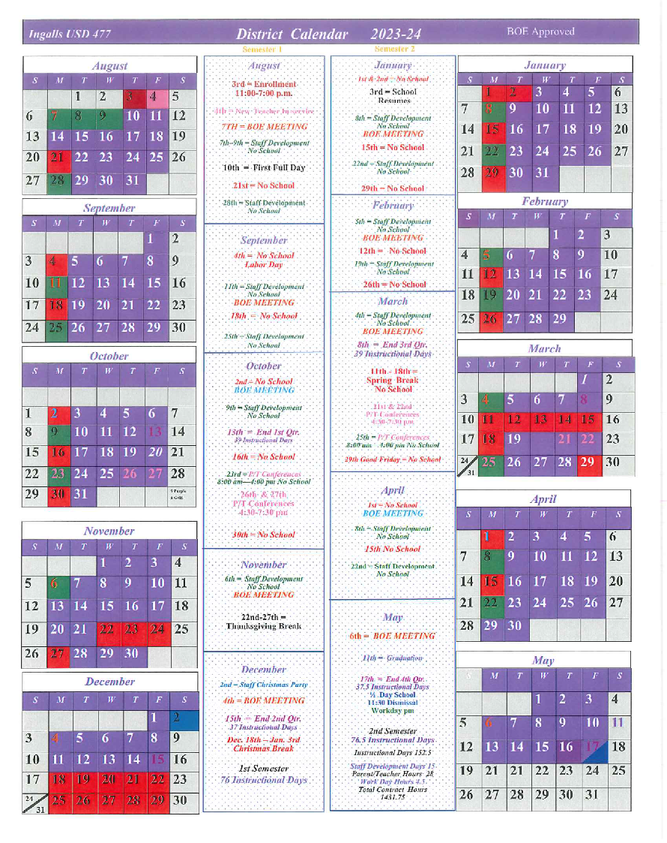

**26**

UNPAID MEAL CHARGES

The district’s meal charging requirements are as follows:

A charge account for students paying full or reduced price for meals may be established with the district. Students may charge no more than $50 worth of meals to this account. Charging of a la carte or extra items to this account will not be permitted.

Any student failing to keep his/her account solvent as required by the district shall not be allowed to charge further meals until the negative account balance has been paid in full. However, such students will be allowed to purchase a meal if the student pays for the meal when it is received. Students who have charged the maximum allowance to this account and cannot pay, will need to bring a sack lunch from home.

At least one written warning shall be provided to a student and his/her parent or guardian prior to denying meals for exceeding the district’s charge limit. If payment of the negative balance is not received within 5 working days of the maximum charge limit being attained, the debt will be turned over to the superintendent or superintendent’s designee for collection in accordance with board policy concerning collection procedures. If the debt is not paid within 10 days of mailing the final notice of the negative account balance under the collection procedures policy, it shall be considered bad debt for the purpose of federal law concerning unpaid meal charges.

Payment for school meals may be made at the school or district office. Students, parents and guardians of students are encouraged to prepay meal costs.

The district will provide a copy of this unpaid meal charges policy to all households at or before the start of school each year and to families and students that transfer into the district at the time of transfer. The terms of this policy will also be communicated to all district staff responsible for enforcing any aspect of the policy. Records of how and when it is communicated to households and staff will be retained.

Unpaid Fees & Negative Account Balances

Unpaid or overdue accounts disrupt accounting practices within the district. All persons who owe overdue fees or have negative account balances with the district shall be notified of the delinquency up to three times in not less than ten (10) day increments by the superintendent or superintendent’s designee via letter sent by US First Class Mail providing that the individual owes the district fees or that a specified account has insufficient funds or a negative balance and the reason for the fees or account withdrawals.

If, within ten days after the second notice was mailed, the debt is not paid in full or arrangements have not been made with the superintendent of superintendent’s designee to pay it, a third and final notice shall be sent to the debtor by mail. Postage and stationary costs may be added to the original bill.

If full payment is not received by the clerk within ten days after mailing of the final notice, authorization for the enforcement of collection may be obtained through the local small claims court in compliance with Kansas statutes or the superintendent or superintendent’s designee may turn the matter over to legal counsel to commence debt collection proceedings on behalf of the district.

When Ingalls USD #477 has determined a delinquent debt as uncollectable and considers it to be bad debt, the district will transfer funds from a non-federal source to be deposited into the food service account.

Approved 6/5/23 **27**